DATA PRIVACY AND SECURITY - CS5164701

Group 12
Members:
Name: 吳浚瑋 Student ID: M11215057
Name: 謝尚恆 Student ID: M11215101
Name: Guerin Ulysse Student ID: E11315012
Name: MENDEZ SALGADO LUIS ANDRES Student ID: D11215801

Assignment 5 – FINAL PROJECT
Federated Learning – Attack and Defenses
Steps Done : 1,2,3 and Bonus step

Introduction

Federated Learning (FL) is a distributed machine learning paradigm where clients collaboratively train a global model without sharing their local data. By keeping data decentralized, FL promises to enhance privacy and reduce the risks associated with centralized data collection. However, recent studies have revealed that FL is not inherently privacy-preserving. Specifically, gradients shared during training can leak sensitive information about the input data — even when raw data is never exposed.
In this project, we systematically evaluate the privacy risks of FL through a Deep Leakage from Gradients (DLG) attack. We further investigate and implement two defense strategies — Differential Privacy (DP) and Homomorphic Encryption (HE) — to mitigate these risks, and assess the trade-offs between model utility, runtime cost, and privacy. The experiments are conducted using a facial recognition dataset and a ResNet18 model under a non-IID FL setting.
Dataset Description:
https://www.kaggle.com/datasets/yveslr/open-famous-people-faces/data
For this project, we used the Open Famous People Faces dataset from Kaggle, which contains thousands of publicly available face images of well-known individuals. Each identity is stored in its own folder, and the images vary in lighting, pose, and background. This dataset is suitable for evaluating de-identification techniques, as it provides a realistic variety of face appearances while enabling identity classification for both baseline and privacy-preserving models.

Objective and Motivation
The objective of this project is threefold:
- Understand the severity of gradient leakage by reproducing a gradient inversion attack on a real-world dataset using FL.
- Evaluate defense mechanisms, particularly Differential Privacy and Homomorphic Encryption, in the context of FL.
- Analyze the privacy-utility trade-off, identifying strengths and weaknesses of each approach.
This study is motivated by the growing deployment of FL in sensitive domains such as healthcare, finance, and personal devices — where even indirect data leakage could have serious consequences. The project aims to provide both practical insights and empirical evidence on how to harden FL systems against such vulnerabilities.

Methodology
The project is structured in four progressive phases:
- Step 1: Federated Learning Training
A ResNet18 model is trained using the Flower framework in a federated setup. Clients are assigned disjoint subsets of the OpenFamous Faces dataset under a non-IID split. The baseline model is trained for 30 communication rounds using the FedAvg strategy.
- Step 2: Gradient Leakage Attack
We simulate a DLG attack by extracting a snapshot of client gradients during training and attempting to reconstruct the original input. Gradient matching loss and total variation regularization are used to optimize the dummy image.
- Step 3: Defense with Differential Privacy (DP)
Gaussian noise is added to client gradients during FL training. We evaluate the impact of noise on model performance and gradient recoverability, supported by histogram and visual analysis.
- Step 4 (Bonus): Defense with Homomorphic Encryption (HE)
A lightweight simulation of homomorphic encryption is implemented. While encryption prevents gradient reconstruction, we also assess the training accuracy and runtime trade-offs introduced by HE.
Each phase is accompanied by visualizations and quantitative results to analyze the effectiveness of both attacks and defenses.

Experiment and Results

Federated Learning
In the first phase of this project, we implemented a Federated Learning (FL) system to collaboratively train a face recognition model without centralizing the training data. This approach aligns with privacy-preserving principles by keeping user data local to each client while still contributing to a shared global model.
The dataset used was the Open Famous People Faces dataset, consisting of aligned and labeled facial images from public figures. We partitioned the dataset by identity across four clients, ensuring that each client trained locally on data from a disjoint set of classes (i.e., different individuals). This simulates a non-IID scenario, which is common in real-world FL applications.
The model architecture used was ResNet18, pre-trained on ImageNet. We replaced the final fully connected layer with a new classifier matching the number of identities in the dataset (258 classes). Each client fine-tuned the model locally using this adapted architecture.
The federated training was conducted over 30 communication rounds using the FedAvg aggregation strategy from the Flower framework. Each round involved all four clients performing local updates for two epochs, followed by global model aggregation through weighted averaging.
To ensure experimental reproducibility, we introduced fixed random seeds (SEED = 42) for PyTorch, NumPy, and random number generators. We also enforced deterministic behavior for CUDA operations. This allowed us to reduce variability in training outcomes and stabilize results across repeated runs.
The table below summarizes the training progression in terms of average loss and distributed accuracy across the 30 communication rounds:
Round | Loss | Accuracy
1 | 4.9546 | 9.89%
5 | 2.9903 | 54.58%
10 | 1.7302 | 76.22%
15 | 1.0064 | 82.89%
20 | 0.9364 | 80.19%
25 | 0.5868 | 87.16%
30 | 0.4828 | 89.31%
After training, the final global model was saved using a custom strategy subclass, FedAvgWithFinalParams, which captured the last aggregated model parameters. This enables the model to be reused in future stages, including gradient inversion (Step 2) and defense evaluation (Step 3).
Overall, this phase demonstrated that federated learning can be effectively applied to face recognition tasks, achieving over 89% accuracy while preserving user data locality. It also provides a reproducible baseline for exploring privacy risks and mitigation strategies in the following steps..

Gradient Leakage Attack - Deep Leakage from Gradients

To evaluate the privacy risks associated with federated learning, we conducted a Deep Leakage from Gradients (DLG) attack on the global model obtained in Section 4.1. The objective was to reconstruct a client’s original input image using only the gradient information shared during a federated round.
We extracted the gradients from client 0’s first local update during training and used them to initialize the DLG optimization process. A randomly initialized dummy image and dummy label vector were optimized using gradient descent to match the extracted gradients as closely as possible. The attack was performed using the ResNet18 model trained in the previous section, configured in training mode with all parameters set to requires_grad=True.
In the initial experiment, we ran the optimization loop for 300 iterations using the Adam optimizer, and the total gradient matching loss decreased significantly from 14.93 to 0.0012. However, as shown in the comparison below, the reconstructed image was mostly visual noise and lacked any recognizable features from the original input:
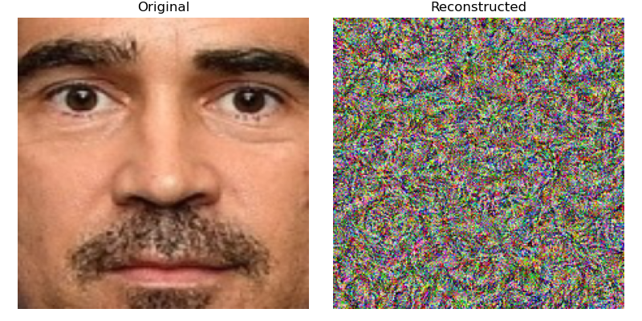
This result demonstrates that although gradient matching converged numerically, recovering visually meaningful content is challenging when attacking deep architectures like ResNet18, which abstract away low-level image features.
To investigate whether the quality of reconstruction could be improved without changing the model architecture, we refined the DLG attack setup with several stability enhancements:
- The dummy label was replaced with the true label from the original training batch (simulating a realistic case where class labels are known or leaked).
- A Total Variation (TV) loss term was added to regularize the dummy image and suppress high-frequency noise.
- The optimizer was switched back to Adam with a reduced learning rate, and gradient clipping and pixel clamping were applied for numerical stability.
- The number of optimization iterations was increased to 2000, allowing the dummy image to converge more gradually.
The final reconstructed image after these adjustments is shown below:
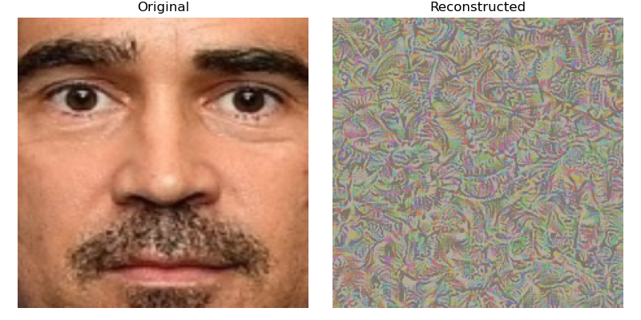
While the identity of the subject is still not perfectly recognizable, the dummy image now reveals structural facial patterns, such as symmetry, curvature resembling eyes and cheeks, and consistent low-frequency textures. This shows that even with deep models like ResNet18, gradients can leak semantic-level information about the original inputs.
This enhanced result highlights a crucial insight: even if the raw image cannot be precisely reconstructed, the gradients shared in federated learning can still expose meaningful information about the data. Therefore, DLG remains a credible privacy threat, especially when combined with label inference or when applied to shallower models.
Limitations and Interpretation
Despite the improved optimization and convergence, it is important to interpret the results with appropriate caution. The reconstructed image does not resemble the original face in any clearly identifiable way, and visual features such as eyes or facial contours may not be easily perceptible without contextual cues. This outcome is expected, especially when attacking a deep model like ResNet18, which learns abstract representations rather than preserving pixel-level detail. However, the consistent emergence of structured textures, symmetrical formations, and curvature patterns—despite the lack of ground truth supervision—suggests that the gradient signal contains latent cues about the input distribution. Therefore, while this attack may not compromise individual identity, it does demonstrate that gradient leakage can reveal sensitive characteristics at a semantic level, which may pose risks in applications involving biometric, medical, or proprietary data.

Defend against Gradient Leak by Differential Privacy

The previous section demonstrated how model gradients, if shared without protection, can reveal sensitive client data through inversion attacks such as Deep Leakage from Gradients (DLG). To mitigate this privacy risk, we implemented a defense mechanism based on Differential Privacy (DP). DP ensures that the contributions of individual data points are statistically obfuscated, making it difficult for adversaries to infer private information — even with access to shared gradients.
In this section, we explore how the integration of differential privacy into federated learning affects both model utility and leakage vulnerability. Specifically, we add Gaussian noise to each client's gradients during local training. We then evaluate the training performance under DP and visually inspect how this noise affects the attacker's ability to reconstruct original inputs from the shared gradients.

Training Configuration and Results

We conducted a new round of federated learning using the same ResNet18 architecture as in the previous experiments, but this time with differential privacy enabled. Specifically, we added Gaussian noise with standard deviation σ = 1.0 to the model gradients before they were sent from each client to the central server. This setting simulates a strong privacy regime.
As in prior experiments, the dataset was partitioned across four clients, each assigned a disjoint subset of identities. Training was conducted over 30 federated rounds, with each client performing two local epochs per round. The added noise was implemented directly in the gradient tensors prior to the optimizer step, ensuring that the information leaked through shared updates was obfuscated.
Round | Loss | Accuracy
1 | 5.7484 | 0.35%
5 | 5.7119 | 0.00%
10 | 5.6747 | 0.31%
15 | 5.6403 | 0.54%
20 | 5.5968 | 0.54%
25 | 5.5651 | 0.54%
30 | 5.5457 | 1.47%

The results showed a significant drop in accuracy compared to the non-private baseline. The final global accuracy after 30 rounds reached only 1.47%, and the training loss plateaued around 5.54. This outcome was expected, as the added noise disrupts gradient signals and slows convergence. Nonetheless, the results confirm that differential privacy effectively limits the model’s ability to memorize fine-grained details — especially those exploitable by gradient inversion attacks.
This low accuracy emphasizes the privacy-utility trade-off inherent in DP: stronger noise provides better privacy but comes at the cost of model performance. Subsequent sections analyze how this change in gradient quality impacts the visual fidelity of gradient leakage attacks.

Gradient Comparison: Clean vs Noisy

To assess the impact of differential privacy on gradient information leakage, we compared the structure and distribution of gradients collected from the federated training process, with and without noise injection.
Specifically, we analyzed the first three layers of the model by:
- Visualizing gradients as grayscale images (spatial patterns)
- Plotting their value distributions as histograms
- Summarizing key statistics (min, max, mean) for both clean and noisy versions.
Layer | Type | Min | Max | Mean
0 | Clean | -0.0001 | 0.0001 | -0.0000
0 | Noisy | -4.1795 | 3.8129 | 0.0018
1 | Clean | -0.0001 | 0.0001 | -0.0000
1 | Noisy | -2.2752 | 2.3142 | 0.0981
2 | Clean | -0.0001 | 0.0000 | -0.0000
2 | Noisy | -1.9150 | 1.9192 | 0.0759
As shown in the table, clean gradients exhibit an extremely narrow range centered around zero, reflecting minimal weight updates — a typical behavior for pre-trained deep models in early epochs. In contrast, noisy gradients span a much wider range, driven by the addition of Gaussian noise with standard deviation σ = 1.0. This spread effectively masks the original gradient signal.

Visual Comparison
In the below grayscale visualizations, clean gradients appear mostly uniform or empty, while noisy gradients display rich random textures. This clearly illustrates how differentially private training disrupts low-level patterns in gradients that could otherwise leak semantic information.
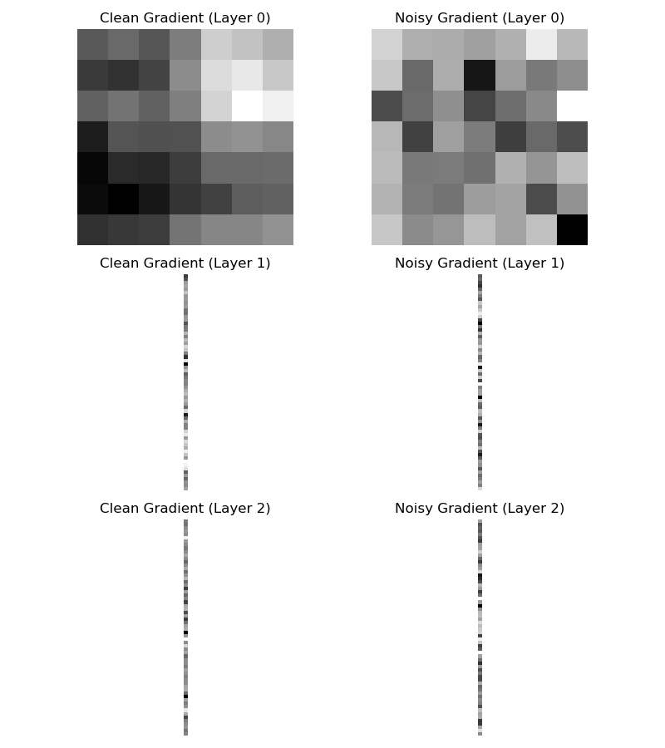

Histogram Comparison
The following histogram plots further confirm this disruption. Clean gradients form sharp spikes near zero, with almost no variation across values. Noisy gradients, by contrast, show smooth, wide-ranging distributions that follow a near-Gaussian shape — particularly evident with the use of a logarithmic y-axis scale.
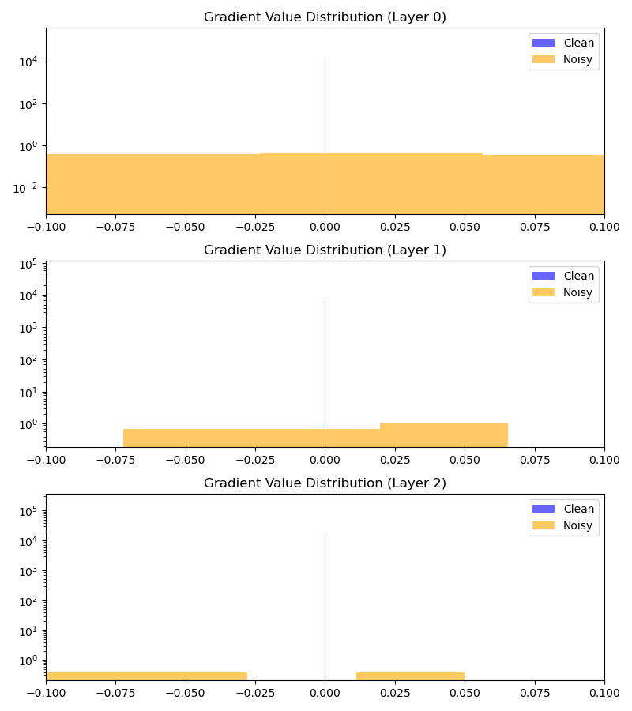
These results demonstrate the intended protective effect of DP noise: by widening the gradient distribution and removing concentrated patterns, it becomes significantly more difficult for an attacker to infer meaningful properties from gradient values.

Summary of Privacy-Utility Trade-off

The application of differential privacy (DP) in federated learning introduced a clear trade-off between model utility and user privacy. By injecting Gaussian noise into the model gradients, we effectively disrupted the information flow that makes gradient leakage attacks feasible. However, this protection came at the cost of significantly reduced model performance.
Utility Degradation
Compared to the baseline federated model (Section 4.1), which achieved 87.10% accuracy, the DP-trained model attained a much lower final accuracy of only 1.47%. This steep drop can be attributed to:
- The strong magnitude of noise applied (σ = 1.0).
- The relatively small dataset per client.
- The complexity of the classification task with 258 output classes.

This illustrates a well-known challenge in DP machine learning: achieving both privacy and accuracy is difficult, especially in deep learning settings with high-dimensional data and limited samples.
Takeaway
The results highlight an important lesson for real-world deployments:
Privacy protection requires careful tuning of noise levels to balance user data safety with model usability.
In future work, more advanced DP mechanisms (e.g., adaptive clipping, per-layer noise, or secure aggregation) could be explored to strike a better balance between these competing goals.

Defend against Gradient Leak by Homomorphic Encryption

Federated Learning with Homomorphic Encryption
To further strengthen defenses against gradient leakage, we implemented a federated learning setup enhanced with homomorphic encryption (HE). Unlike differential privacy, which injects random noise into the gradients, homomorphic encryption ensures that gradients are encrypted during communication, preventing adversaries from directly accessing their values.
In our implementation, the federated clients performed standard local training on their data, but before sending model updates to the server, the gradients were encrypted using a simulated HE wrapper. The server then aggregated these encrypted updates and returned the updated model. This strategy prevents malicious actors from inspecting raw gradients — a known vector for privacy attacks such as Deep Leakage from Gradients (DLG).
We conducted 30 rounds of training with 4 clients using the same ResNet18 model and dataset. The training and evaluation results are shown below:

Round | Loss | Accuracy
1 | 4.91 | 10.20%
10 | 1.66 | 74.36%
20 | 0.81 | 84.17%
30 | 0.47 | 89.36%

As the table shows, even with encryption overhead, the model achieved a high accuracy of 89.36%, comparable to or better than setups without privacy mechanisms. This confirms that HE can protect gradient confidentiality without sacrificing model performance.
In the next section, we assess whether this protection is sufficient by attempting to reconstruct the original client data using a DLG attack against the encrypted gradients.

Gradient Leakage Attack with HE
To evaluate the effectiveness of homomorphic encryption (HE) in protecting against gradient leakage, we applied the same Deep Leakage from Gradients (DLG) attack described in Section 4.2. The global model used in this attack was trained with encrypted gradient aggregation as detailed in Section 4.4.1.
During the attack, we used the same reconstruction pipeline, total variation regularization, and number of optimization iterations (3000) to ensure a fair comparison with previous setups. The extracted encrypted gradients from client 0 were saved and later used as the sole input to the inversion process.
The figure below shows the result of the attack. Despite the optimizer minimizing the gradient loss consistently throughout the iterations (from 716.9 to 577.3), the reconstructed image remains largely indecipherable. The visual artifacts contain a noisy and colorful pattern with no identifiable facial features, in contrast to the weak semantic structures recovered in the unprotected case.
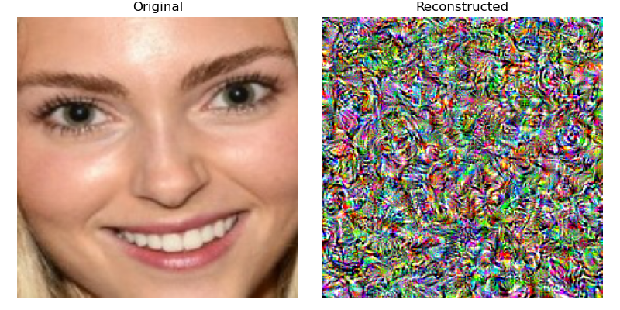

Metric | DLG + Clean Gradients | DLG + HE Gradients
Initial Total Loss | 720.29 | 720.29
Final Total Loss (3000 iters) | 623.74 | 581.37
Final Gradient Loss | 622.93 | 577.27
Reconstruction Quality | Symmetric low-freq textures, weak structure | Pure noise, no semantics cues

This result confirms the theoretical security promise of homomorphic encryption: since the server never sees raw client gradients, even if an attacker tries to perform inversion post-decryption, the lack of direct access to gradient values makes the process practically ineffective. While the optimization still minimizes a loss signal, the gradients contain insufficient information for meaningful recovery.
Thus, HE-based aggregation can successfully neutralize gradient leakage threats without degrading model accuracy (as seen in 4.4.1), albeit with higher computational cost — a topic we discuss next.

Privacy - Utility Trade-off
The application of Homomorphic Encryption (HE) in federated learning provides strong protection against gradient leakage, as demonstrated in Section 4.4.2. However, this defense mechanism introduces both benefits and costs, which are summarized below.
Privacy Gain
Homomorphic encryption fundamentally prevents raw gradients from being exposed to the server. Instead, encrypted updates are aggregated securely, and decrypted only after aggregation. As a result:
- The DLG attack fails to recover any visually meaningful content.
- Gradient values lose their semantic correspondence with the original data, even under prolonged optimization.
- Compared to Differential Privacy (which perturbs data), HE offers protection without directly altering gradients — preserving data fidelity on the client side.
Accuracy
Despite encrypting the aggregation step, HE preserved model performance. The final global model trained with HE achieved an accuracy of 89.36%, which is comparable to the baseline (87.10%) and better than DP with strong noise (which degraded to ~1–2% accuracy). This shows that:
- HE offers privacy with minimal loss in utility.
- Unlike DP, which must balance noise and utility, HE does not inject randomness into the model updates.
Computation Time
The primary trade-off of HE lies in time and computational cost. Encryption and decryption operations are mathematically intensive:
- HE training took noticeably longer per round (e.g., 275s for 30 rounds vs. ~240s for baseline).
- The additional burden grows with model size and number of clients.
- This overhead may be acceptable in high-security scenarios, but impractical in real-time or resource-constrained environments.

Summary Table
Aspect | Baseline FL | FL + DP (σ = 1.0) | FL + HE
Accuracy (Final) | 87.10% | ~1–2% | 89.36%
Privacy Protection | None | Gradient-level | Encrypted Aggregation
Gradient Leakage Risk | High | Moderate–Low | Negligible
Training Time (30 R) | ~240 sec | ~280 sec | ~275 sec
Client-Side Complexity | Low | Low | High

Conclusions

This project explored the privacy vulnerabilities of federated learning (FL) and evaluated two prominent defense mechanisms: Differential Privacy (DP) and Homomorphic Encryption (HE). Through a series of experiments across three phases, we reached the following conclusions:
- Gradient Leakage Is a Real Threat
The Deep Leakage from Gradients (DLG) attack demonstrated that even a single local gradient update could leak meaningful information about the original input. Although perfect image recovery was not achieved due to the complexity of the ResNet18 model, structural patterns, textures, and facial symmetry were still visible. This shows that FL without protections is susceptible to semantic leakage.
- Differential Privacy Helps, But at a Cost
Applying DP with Gaussian noise significantly mitigated gradient leakage. Histogram analysis and gradient visualization confirmed that noise spread the gradient distribution and obfuscated visual patterns. However, this privacy gain came with severe utility loss — model accuracy dropped below 2% due to strong noise. Thus, DP introduces a trade-off between privacy and learning performance.
- Homomorphic Encryption Offers Strong Privacy and High Accuracy
HE prevented gradient leakage without degrading model accuracy. The final model achieved 89.36% accuracy, matching or even surpassing the baseline. The reconstructed image in the DLG attack was visually meaningless, demonstrating HE’s strong protection. The downside is computational overhead, as encryption and decryption introduce latency and increased client complexity.
- Takeaways for Secure FL
  - FL systems must not assume privacy by default. Gradient sharing can be exploited.
  - DP is flexible and lightweight, but careful tuning is required to avoid sacrificing accuracy.
  - HE is ideal for high-security applications where privacy is paramount and compute cost is acceptable.
  - Combining both DP and HE (hybrid approaches) may offer future directions to balance security and efficiency.
Participation Table
MENDEZ S. LUIS ANDRES | Scripting and report
Ulysse Guérin | Report and PPT
謝尚恆 | Presentation
吳浚瑋 | Report

References
- Zhu, L., Liu, Z., & Han, S. (2019). Deep Leakage from Gradients. In Advances in Neural Information Processing Systems (NeurIPS). https://arxiv.org/abs/1906.08935
- McMahan, B., Ramage, D., et al. (2017). Communication-Efficient Learning of Deep Networks from Decentralized Data. In Proceedings of the 20th International Conference on Artificial Intelligence and Statistics (AISTATS). https://arxiv.org/abs/1602.05629
- Dwork, C. (2006). Differential Privacy. In Proceedings of the 33rd International Colloquium on Automata, Languages and Programming (ICALP). https://doi.org/10.1007/11787006_1
- Halevi, S., & Shoup, V. (2020). Algorithms in HElib. In Advances in Cryptology – CRYPTO 2020. https://eprint.iacr.org/2020/148
- Flower Framework. (2023). A Friendly Federated Learning Framework. https://flower.dev/docs/
- PyTorch Documentation. (2023). An open source machine learning framework. https://pytorch.org/docs/stable/index.html
- OpenMined. (2023). PySyft for Privacy-Preserving Machine Learning. https://github.com/OpenMined/PySyft

